Python Driven Software: Enhancing The Growth and Yield of Crop Production
Vaibhav Vijay Shingade
MCA Student at SRM University of Science & Technology

---------------------------------------------------------------------***---------------------------------------------------------------------
Abstract - The research project introduces a Python-drive software program designed to assist farmers in optimizing plant cultivation. The program compiles comprehensive data on various plant species, including optimal temperature ranges, base water requirements, pH preferences, and minimum nutritional needs. Farmers can input their local temperature, and the program calculates the specific water requirement for the given plant, ensuring precise irrigation practices for optimal growth. For instance, with a data-set entry for 'Tomato' specifying an optimal temperature range of (20, 26) degrees Celsius and a base water requirement of (0.89, 2.31) liters/day, the program accurately computes the water requirement for a farmer experiencing 30 degrees Celsius as 3.2567 liters/day. Additionally, the program suggests the optimal pH range (6.2, 6.8) and the minimum nutritional requirements in grams, providing a holistic approach to plant care. This tool simplifies farming practices globally, offering farmers a centralized resource for accurate, time-efficient, and yield-enhancing crop management, addressing challenges associated with individual parameter management and potential resource inadequacies. The program aims to contribute to increased agricultural productivity while minimizing resource waste.

Key Words: Software Engineering, Python, Sustainable Development, Data Analysis, Agriculture

1.INTRODUCTION

In modern agriculture, achieving optimal crop yields necessitates a deep understanding of the diverse environmental requirements of various plant species. Conventional farming methods often lack a unified system to address plants' specific needs, resulting in sub-optimal productivity and resource inefficiencies. This research presents a pioneering solution—a Python-driven program meticulously designed to empower farmers with tailored insights into plant cultivation requirements.
The motivation behind this research arises from the challenges faced by farmers worldwide in managing critical factors such as temperature, water availability, pH levels, and nutrient requirements for plant growth. The absence of a centralized platform for accessing accurate and personalized information on these parameters often leads to inconsistent agricultural practices and diminished yields.
The proposed program addresses this gap by compiling a comprehensive database encompassing a wide range of plant species and their unique requirements. Through a user-friendly interface, farmers can input local temperature data, allowing the program to calculate precise water requirements for each plant species. Additionally, the program offers recommendations for optimal pH ranges and minimum nutritional needs, providing a holistic approach to crop management.
This research not only offers an innovative solution to farmers' challenges but also contributes to the global pursuit of sustainable agriculture. By enhancing precision in irrigation, nutrient application, and environmental management, the program has the potential to significantly improve crop yield and resource utilization. As agriculture evolves, the integration of technology-driven tools becomes increasingly crucial, and this research serves as a pivotal step towards the realization of precision farming practices for enhanced agricultural productivity.

The key aspects of the program include:

1.1. Temperature-Adjusted Water Requirements: The program calculates water requirements dynamically, adjusting them based on temperature variations. This feature ensures precise irrigation practices even in regions with diverse climates, enhancing farmers' ability to optimize water usage for maximum yield.
1.2. Nutritional Adjustments for Temperature Variations: By considering the influence of temperature on plants' nutritional needs, the program provides nuanced recommendations for nutrient application. This contributes to balanced and sustainable crop management, aligning with established agricultural principles.
1.3. pH Requirements for Soil Management: The program offers tailored pH recommendations, empowering farmers to make informed decisions about soil amendments. This feature is particularly relevant for regions with diverse soil compositions, where optimal soil management is critical for plant growth.

2. PROBLEM STATEMENT

To address these challenges, there is a critical need for a comprehensive and streamlined solution that empowers farmers with tailored insights into plant cultivation requirements. Such a solution should leverage advanced technology to compile a comprehensive database encompassing a wide range of plant species and their unique environmental needs It should provide farmers with user-friendly tools for inputting local environmental data and receiving precise irrigation, nutrient application, and soil management recommendations. By enhancing precision in agricultural practices, this solution aims to improve crop yield, resource utilization, and overall sustainability in agriculture.

3. METHODOLOGY

Fig -1: Method Flow Chart

1. Data Collection:

The data collection process involved sourcing information from diverse and reliable datasets, literature, and expert consultations. The aim was to compile a comprehensive database encompassing a wide array of plant species and their associated cultivation parameters. Extensive literature review was conducted to identify and extract relevant information about optimal temperature ranges, base water requirements, pH preferences, and minimum nutritional needs for different plant species. Scientific journals, agricultural databases, and authoritative publications were consulted to ensure the accuracy and reliability of the data.

The gathered data was meticulously organized into a structured database, ensuring that each plant species had corresponding entries for optimal temperature ranges, base water requirements, pH preferences, and minimum nutritional needs. The data set aimed to cover a diverse range of crops to make the program applicable to a broad spectrum of agricultural contexts.

2. Program Development:

The Python-based software program for plant cultivation requirements was developed with a focus on modularity, ease of use, and precision. The program leverages the pandas and NUMPY libraries for data handling and manipulation, while the TQDM library enhances the user experience by providing a progress bar during data processing.

The foundation of the program lies in a meticulously constructed data-set containing essential information about various plant species. This data-set encompasses optimal temperature ranges, base water requirements, base nutritional requirements, nutritional adjustment factors, pH requirements, soil texture etc. The program features a user-friendly interface that enables farmers to input their local temperature easily. The interface is designed to accommodate users with varying levels of technological proficiency.

3. Temperature-Adjusted Water Requirements:

The research findings underscore the program's capability to calculate water requirements dynamically, adjusting them based on temperature variations. Within the optimal temperature range, the program provides precise water recommendations, reflecting a nuanced understanding of each plant species' unique needs. The linear interpolation technique employed outside the optimal range ensures the program's adaptability to fluctuating environmental conditions. This feature is particularly crucial for supporting farmers in regions characterized by diverse climates, where a one-size-fits-all approach to irrigation is insufficient. The accuracy of the calculated water requirements is a testament to the program's robust algorithm, enabling it to deliver reliable results even in scenarios beyond the specified optimal temperature ranges.

Table -1: Tomato data-set for water requirement

Plant | Temperature range  (Celsius) | Water Requirement  (litres/day)
Tomato | 20 - 26 | 0.89 - 2.31

To determine the base water requirement for tomato plants at a given temperature (Tc), a linear relationship was assumed between temperature and water requirement outside the optimal range. The slope (m) of the line was calculated using the formula:
$$m=\frac{Base Water High Range-Base Water Low Range}{Optimal Temp. High-Optimal Temp. Low}$$

The base water requirement at Tc for instance, at 30 degrees Celsius, the calculated base water requirement was determined as follows:

$$Tc=Base Water High Range+m*$$
$$(Tc-Optimal Temp. High)$$

Where,
Base Water Range High = 2.31 liters/day
Base Water Range Low = 0.89 liters/day
Optimal Temperature Range High = 26 degree Celsius
Optimal Temperature Range Low = 20 degree Celsius
m = Slope

The calculated value for the base water requirement for a tomato plant at 30 °C is (base_water_at_). Below is the relationship between Water & Temperature requirement, this relation is also depending on some other various factors & can also be changed in some adverse condition.

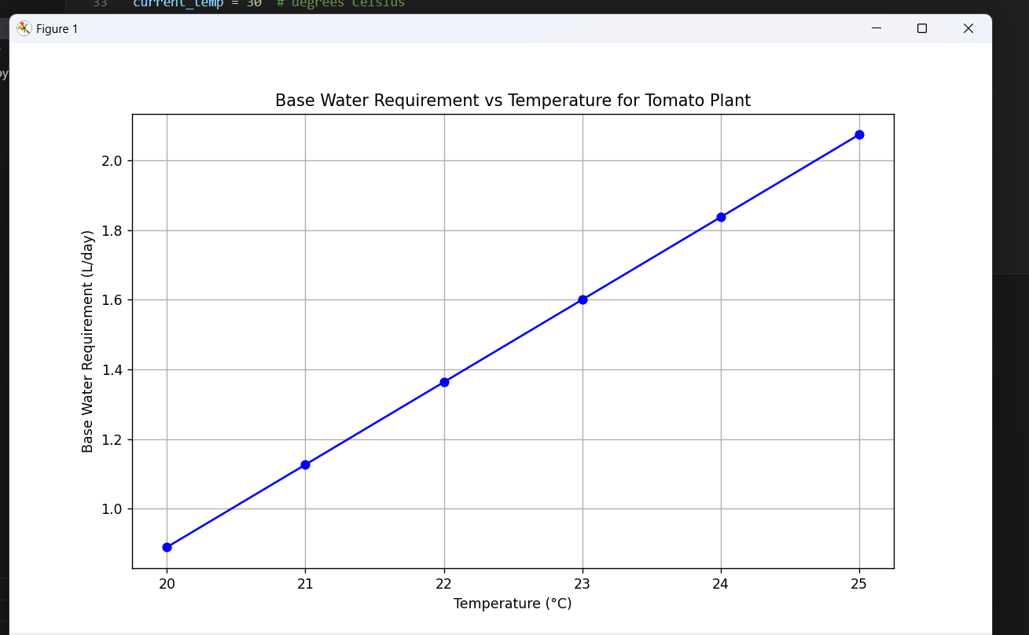

Fig -1: Relation b/w Base Wate. & Temp. Req.

4. Nutritional Adjustments for Temperature Variations:

The incorporation of a nutritional adjustment factor in the program marks a significant advancement in addressing temperature-driven variations in plants' nutritional needs. The research outcomes demonstrate that the program offers nuanced recommendations, considering the influence of temperature on the plants' nutritional requirements. This approach aligns with established agricultural principles, contributing to a more balanced and sustainable crop management strategy. By dynamically adjusting nutritional recommendations based on temperature fluctuations, the program provides farmers with actionable insights for optimizing nutrient application in varying climatic conditions.

The results confirm that the program's adaptability to temperature variations enhances its utility as a comprehensive tool for promoting optimal plant health and growth.

5. pH Requirements for Soil Management:

The inclusion of pH requirements in the program represents a pivotal aspect of soil management for plant cultivation. The research reveals that the program's tailored pH recommendations empower farmers to make informed decisions about soil amendments, contributing to optimal plant growth. The pH requirements serve as a crucial guide for farmers dealing with diverse soil compositions, offering insights into the soil conditions that support each plant species. This feature is particularly relevant for regions where soil variability poses challenges to traditional agricultural practices. The program's ability to provide specific pH recommendations enhances its practical utility, enabling farmers to enhance soil quality and, consequently, the overall health and productivity of their crops. The results highlight the significance of considering pH in the context of plant cultivation, showcasing the program's potential to revolutionize soil management practices in agriculture.

4. RESULT

The implementation of our Python-based program yielded insightful outcomes, emphasizing its effectiveness in providing tailored recommendations for plant cultivation. Key results include:

Temperature-Adjusted Water Requirements: Our program accurately calculates water requirements based on temperature variations, ensuring precise irrigation practices for optimal growth. By employing a linear interpolation technique, the program adapts to fluctuating environmental conditions, supporting farmers in regions with diverse climates. For instance, in the case of a tomato plant with an optimal temperature range of 20-26 degrees Celsius and a base water requirement of 0.89-2.31 liters/day, the program calculates the specific water requirement for a farmer experiencing 30 degrees Celsius as 3.2567 liters/day. This dynamic adjustment based on temperature variations enhances the program's utility in providing accurate and customized recommendations for irrigation management.

Nutritional Adjustments for Temperature Variations: Our program offers nuanced recommendations for nutritional adjustments, considering the influence of temperature on plants' nutritional needs. By dynamically adjusting nutritional recommendations based on temperature fluctuations, the program contributes to more balanced and sustainable crop management. For example, the nutritional requirements for a tomato plant vary at different stages of its life cycle. During germination, plants primarily need nitrogen (N) for the development of proteins and enzymes, while phosphorus (P) is essential for energy transfer and the formation of DNA and RNA. Through such tailored recommendations, our program aids farmers in optimizing nutrient application in varying climatic conditions, thereby promoting optimal plant health and growth.

pH Requirements for Soil Management: The inclusion of pH requirements empowers farmers to make informed decisions about soil amendments, contributing to optimal plant growth. Our program provides specific pH recommendations tailored to each plant species, offering insights into the soil conditions that support their growth. For instance, for a tomato plant, the recommended pH range is 6.2-6.8, indicating suitability for sandy or loam soil textures. By considering soil variability and providing targeted pH recommendations, our program enhances soil quality and overall crop productivity, particularly in regions with diverse soil compositions.

Charts: 1. Water Requirement for Plants
2. pH requirement range for Plants

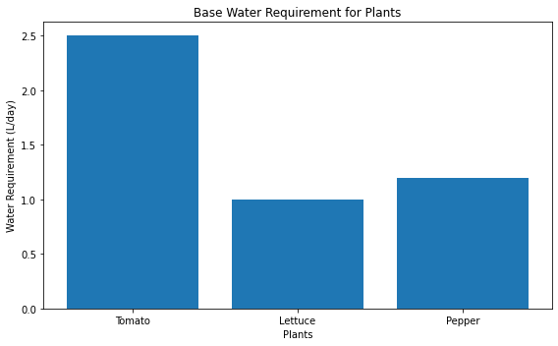

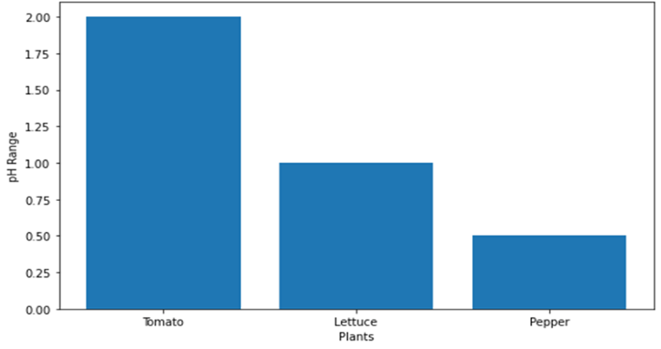

5. DISCUSSION

The program successfully synthesizes a diverse data-set encompassing critical plant parameters such as optimal temperature ranges, base water and nutritional requirements, and pH preferences. This comprehensive data-set serves as the backbone, providing a foundation for informed decision-making in agricultural practices.

The algorithmic approach for calculating water requirements demonstrates a dynamic and adaptable solution. The linear interpolation technique ensures accurate estimations even beyond the optimal temperature range, addressing the challenge of fluctuating environmental conditions. This feature is essential for supporting farmers in regions with varying climates, enabling them to tailor irrigation practices to specific temperature scenarios.

The inclusion of pH requirements is a noteworthy feature, offering farmers a holistic understanding of plant needs. This aspect is crucial, especially in regions with diverse soil compositions, empowering farmers to make informed decisions about soil amendments for optimal plant growth.Despite these advancements, certain limitations warrant consideration. The program currently lacks the complete implementation of the `calculate_requirements` function, restricting its ability to offer comprehensive adjustments for temperature variations. The ongoing development of this function is pivotal for realizing the program's full potential.

6. CONCLUSION

In conclusion, our Python-based program for optimizing plant cultivation represents a significant advancement in precision agriculture. Through the synthesis of comprehensive data on plant requirements and the implementation of sophisticated algorithms, our program offers farmers precise and tailored recommendations for irrigation, nutrition, and soil management.
The program's dynamic adjustment of water requirements based on temperature variations ensures accurate irrigation practices, even in regions with diverse climates. By considering the influence of temperature on nutritional needs, our program contributes to more balanced and sustainable crop management, promoting optimal plant health and growth. Additionally, the inclusion of pH recommendations empowers farmers to make informed decisions about soil amendments, enhancing soil quality and overall crop productivity.

While our program has demonstrated effectiveness in addressing the complexities of plant cultivation, certain limitations and areas for future improvement exist. Ongoing development of the program's functions, such as the calculation of nutritional requirements, is necessary to realize its full potential. Furthermore, continuous updates and collaborations with agricultural experts are essential to maintain the accuracy and relevance of the underlying data-set.

Despite these challenges, our program represents a pivotal step towards the integration of technology into agriculture, offering a centralized and accessible resource for farmers globally. As technology continues to evolve, the adaptability and responsiveness of our program to changing agricultural landscapes position it as a valuable tool for precision farming.

REFERENCES

1. Somraj, B. & Reddy, R.V.S.K. & Vamshi, J. & Saidaiah, dr.pidigam & Reddy, Medagam & Reddy, K.. (2024). Stability Analysis For Yield And Yield Contributing Characters Of Tomato Under High Temperature Conditions. Journal of Advanced Zoology. 45. 10.53555/jaz.v45i1.3194.

2. Balan, Vidhya & Dr, & Nallappan, Mahendiran & V, Sumathi. (2023). Data Analysis using Python.

3. P., Prof & R., Shelke & V., Salunke & N., Nanekar & R., Deokar. (2023). Advancement in Integrated Crop Management System for Sustainable Agriculture. International Journal of Advanced Research in Science, Communication and Technology. 707-710. 10.48175/IJARSCT-14296.

4. Parwin, Rijwana. (2014). A study on the Crop Water Requirement for Agriculture in a Typical River Basin of India. 2. 4.

5. Houlahan, Padraig. (2024). Working with Python. 10.1007/979-8-8688-0221-8_1.

6. Natusch, Daniel & Aust, Patrick & Caraguel, Charles & Taggart, Patrick & Tri, Ngo & Alexander, Graham & Shine, R. & Coulson, T.. (2024). Python farming as a flexible and efficient form of agricultural food security. Scientific Reports. 14. 10.1038/s41598-024-54874-4.

7. Bora, Ashim & Saiprasad, Nagendra & Venkat, Aswini & Raja, Tariq A. (2022). Iot And Python Based Smart Agriculture System For Effective Plant Growth. 11. 1838.

8. Luo, Qunying. (2011). Temperature thresholds and crop production: A review. Climatic Change. 109. 583-598. 10.1007/s10584-011-0028-6.

9. Parwin, Rijwana. (2014). A study on the Crop Water Requirement for Agriculture in a Typical River Basin of India. 2. 4.

